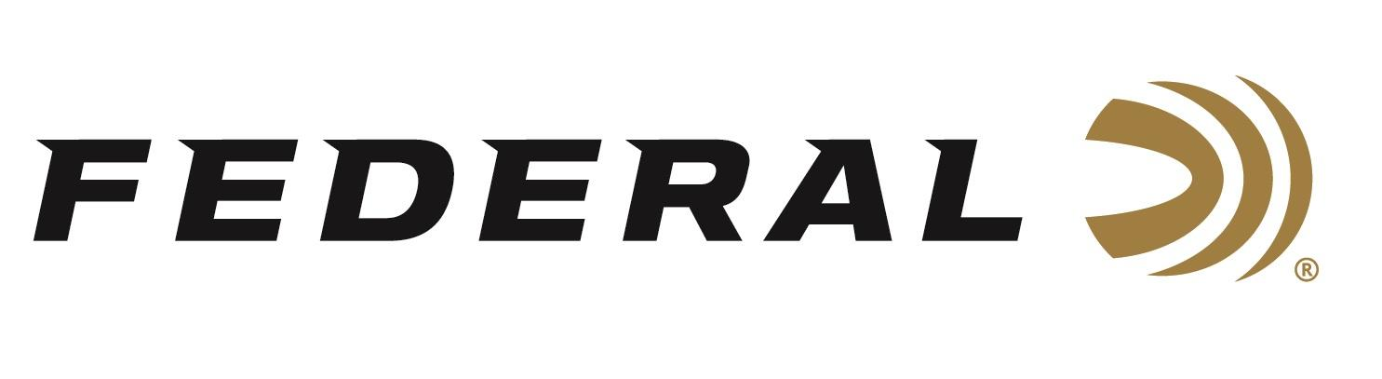

FOR IMMEDIATE RELEASE

Free onX Hunt Trial with the Purchase of Federal’s MeatEater Ammunition

ANOKA, Minnesota – June 2, 2020 – Begin e-scouting for your next hunt with a free two-month onX Hunt trial with the purchase of Federal Ammunition’s MeatEater line up of ammunition. Buy at least two boxes of Federal Premium MeatEater Trophy Copper rifle, 3rd Degree or Bismuth shotshell ammunition, or CCI MeatEater Copper-22, Mini-Mag or Maxi-Mag rimfire ammunition and get a redemption code for a free 2-month Premium Membership* to onX Hunt. This promotion is for new onX Hunt members only.

“This is an exciting opportunity for fans of MeatEater, Federal, and onX,” says Vice President of Trade Marketing Ryan Krantz at Federal. “There is real value for the hunter in this promotion by knowing where you are, the change in terrain, and property boundaries while pursuing your game with premium ammunition. It is a perfect pairing to increase your odds of success.”

Extract maximum performance from your favorite cartridge with Federal Premium Trophy Copper, the freezer filler rifle ammunition of MeatEater's Steven Rinella. The loads provide pinpoint accuracy and aggressive expansion, yet the copper, polymer-tipped bullet retains up to 99 percent of its weight for deep penetration on a wide range of medium and big game.

Before the hunt, e-scout with the desktop and phone-based app to make a pre-hunt game plan. Then hunters can use in-app features to make the most of real-time encounters, ensuring they are in the right place at the right time to harvest wild game.

“At MeatEater, we consistently rely on both Federal Ammunition and onX Hunt for premium performance in field,” says Josh Prestin, VP of Business Development at MeatEater. “Accuracy and precision are hallmarks of both brands, so this is a natural partnership that we are excited to be a part of and share with our audience.”
The Hunt Harder promotion started on 6/1/2020 and runs through 7/31/2020. Go to www.federalpremium.com/promotions for all the details on this pairing of premium partners.

Federal ammunition can be found at dealers nationwide or purchased online direct from Federal. For more information on all products from Federal or to shop online, visit www.federalpremium.com.
Press Release Contact: JJ Reich
Senior Manager – Press Relations
E-mail: VistaPressroom@VistaOutdoor.com

About Federal Ammunition
Federal, headquartered in Anoka, MN, is a brand of Vista Outdoor Inc., an outdoor sports and recreation company. From humble beginnings nestled among the lakes and woods of Minnesota, Federal Ammunition has evolved into one of the world's largest producers of sporting ammunition. Beginning in 1922, founding president, Charles L. Horn, paved the way for our success. Today, Federal carries on Horn's vision for quality products and service with the next generation of outdoorsmen and women. We maintain our position as experts in the science of ammunition production. Every day we manufacture products to enhance our customers' shooting experience while partnering with the conservation organizations that protect and support our outdoor heritage. We offer thousands of options in our Federal Premium and Federal lines-it's what makes us the most complete ammunition company in the business and provides our customers with a choice no matter their pursuit.

